(674585, Stephane Nigaba, Lab Inter-Vlan Routing)

In this lab, we’ll walk through a complete setup of inter-VLAN routing using a Router-on-a-Stick (ROAS) topology. This is a core concept in modern enterprise networks, where multiple VLANs (Virtual LANs) are used to segment traffic, and a single router is used to enable communication between them.
We will:
- Create VLANs for different groups of users
- Assign switchports to VLANs
- Use router subinterfaces to route between VLANs
- Verify everything with ping and ipconfig

PART 1: UNDERSTANDING TOPOLOGY
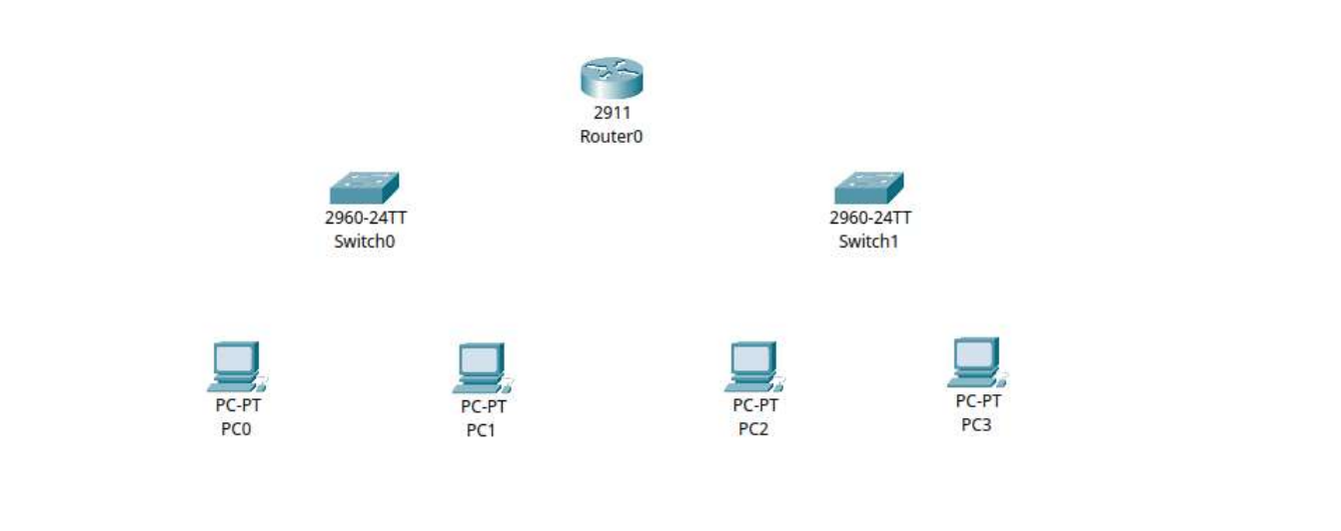

PART 2: Device Setup and Cabling
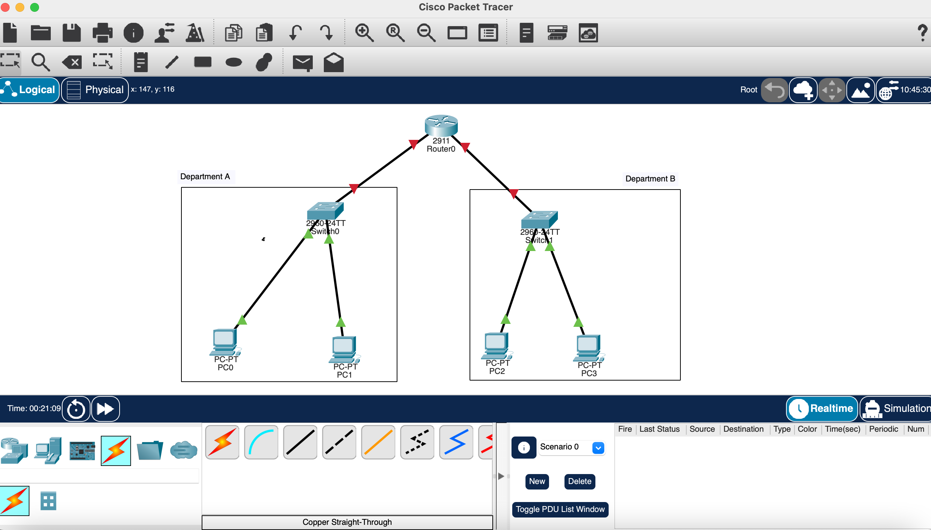

Part 3: VLAN CONFIGURATION AND PORT ASSIGNMENT
Switch 0 configuration:
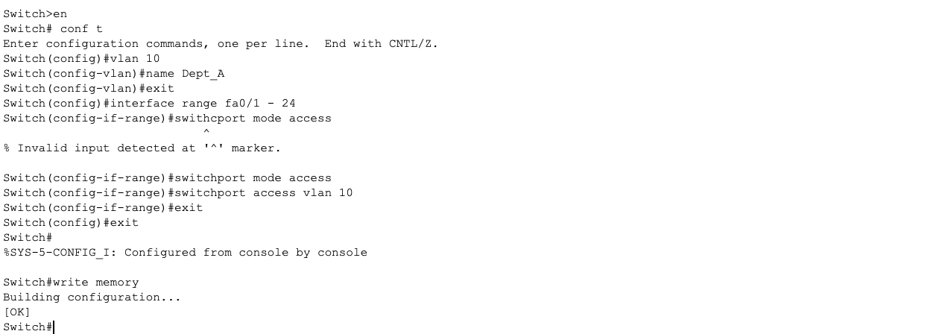

Verifying Vlan10 configuration
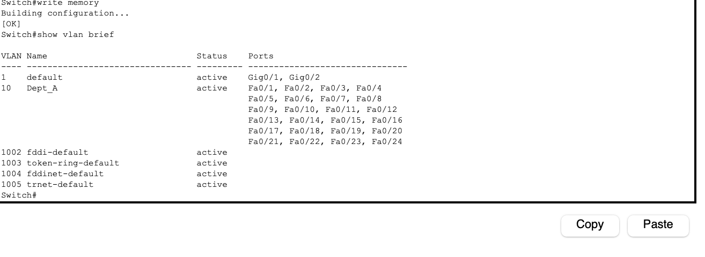

Switch 1 configuration
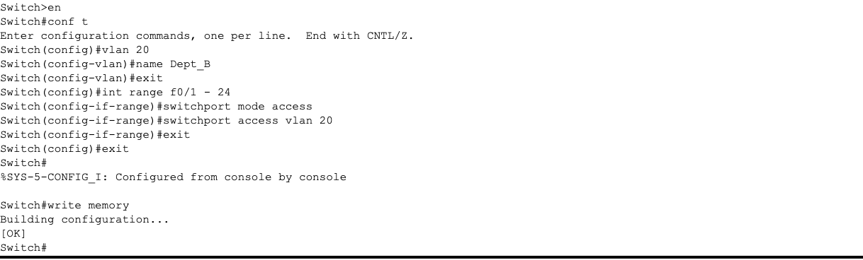
Verifying vlan 20 configuration
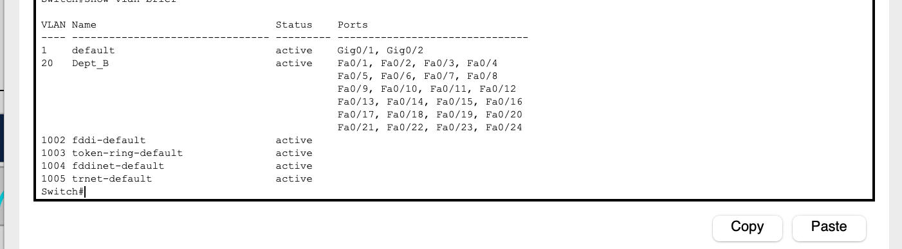

Part 4 : Router Interface Configuration
For Vlan 10 (Dept A):
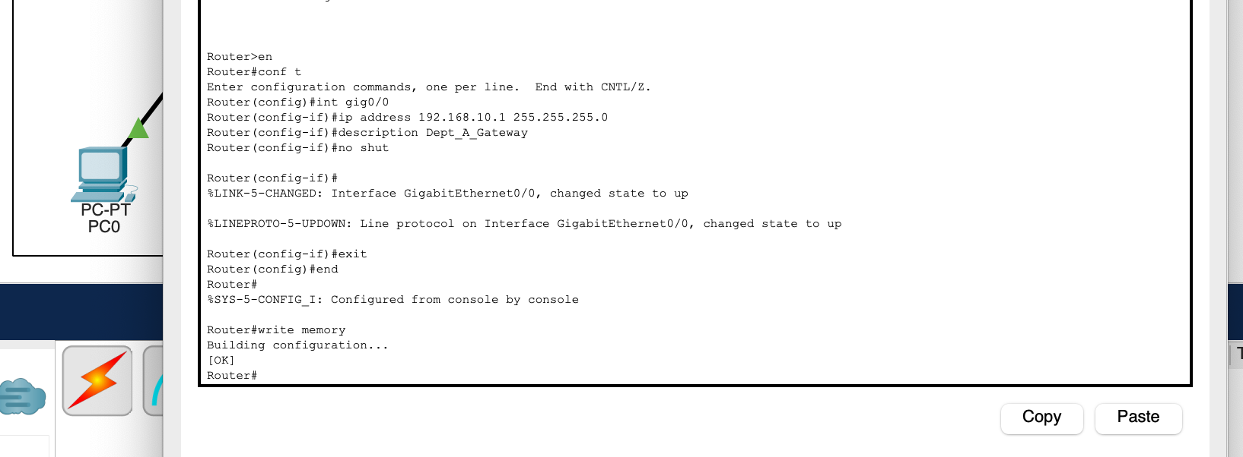
For Vlan 20 (Dept B):
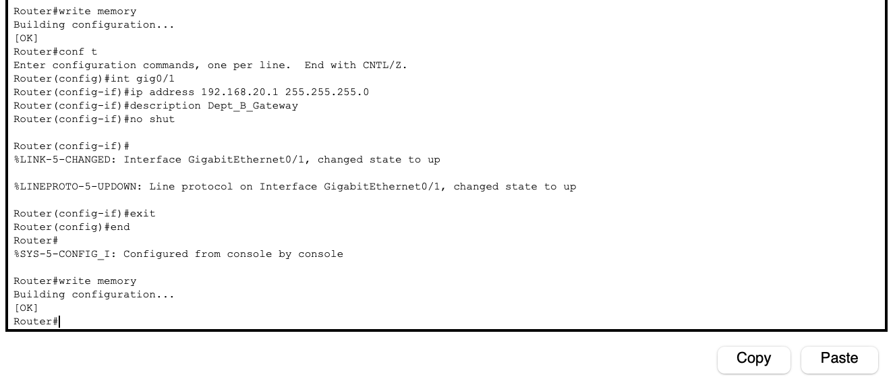

PART 5: CONFIGURING PC IP SETTINGS
Each PC will have a static IP address and default gateway

PC0:
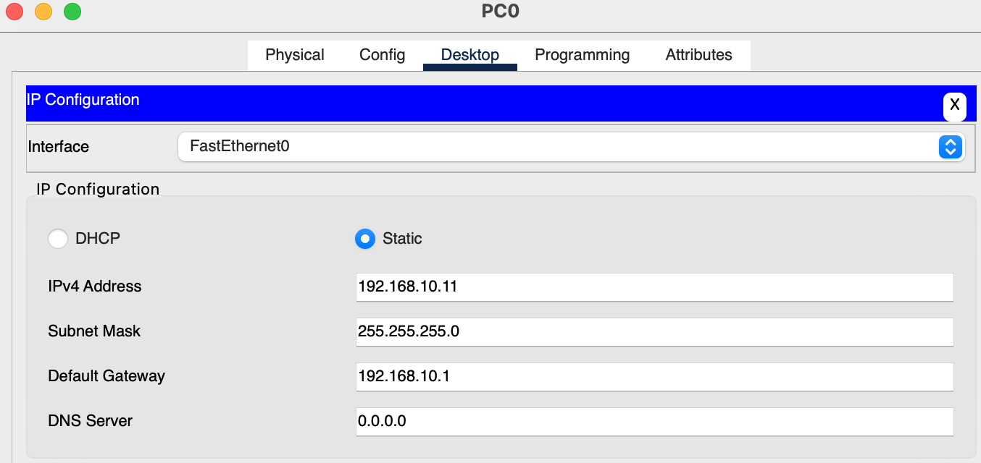

PC1
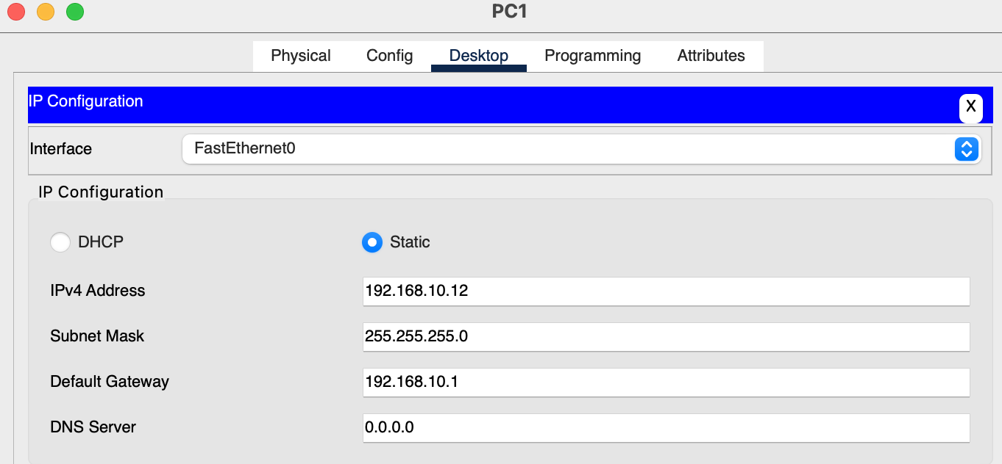

PC2
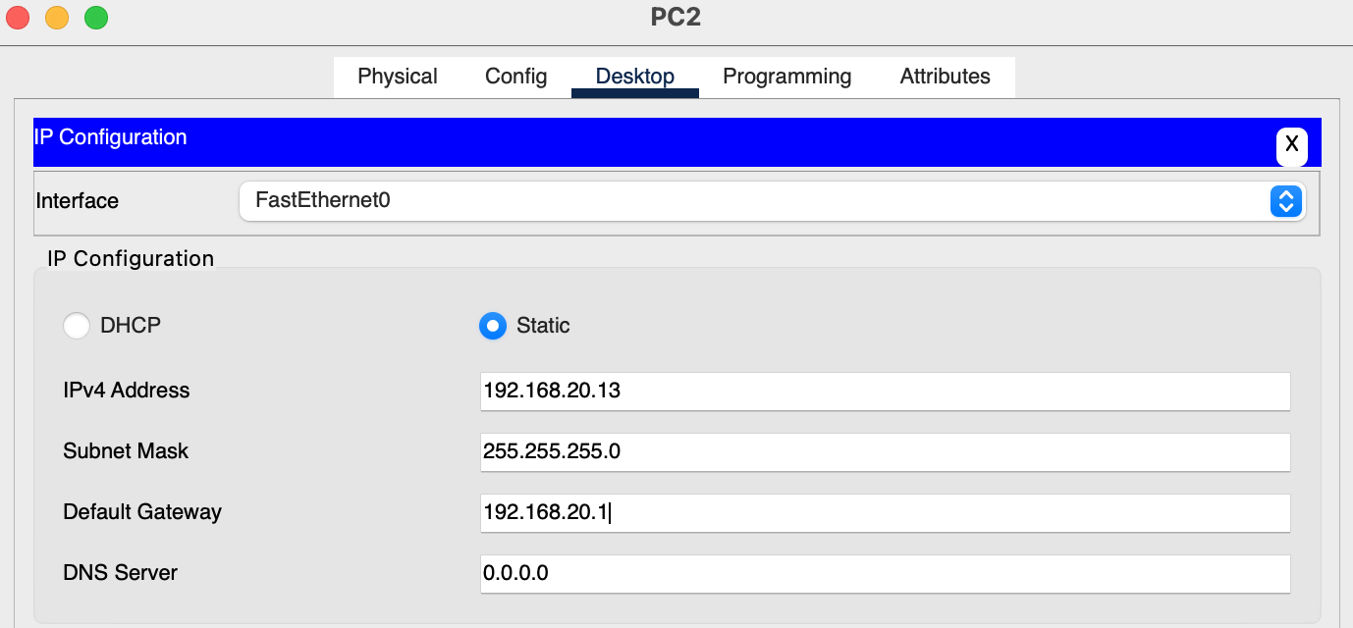
PC3
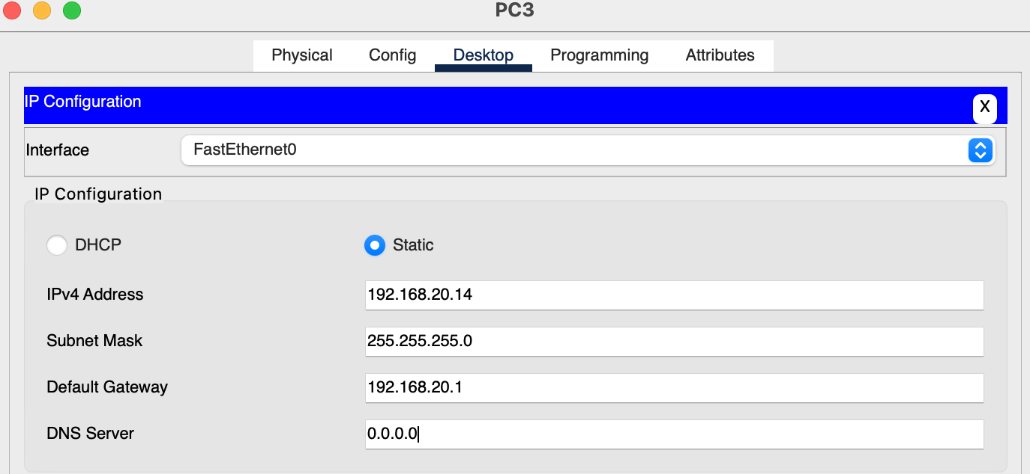

Successful configuration with Green Arrows
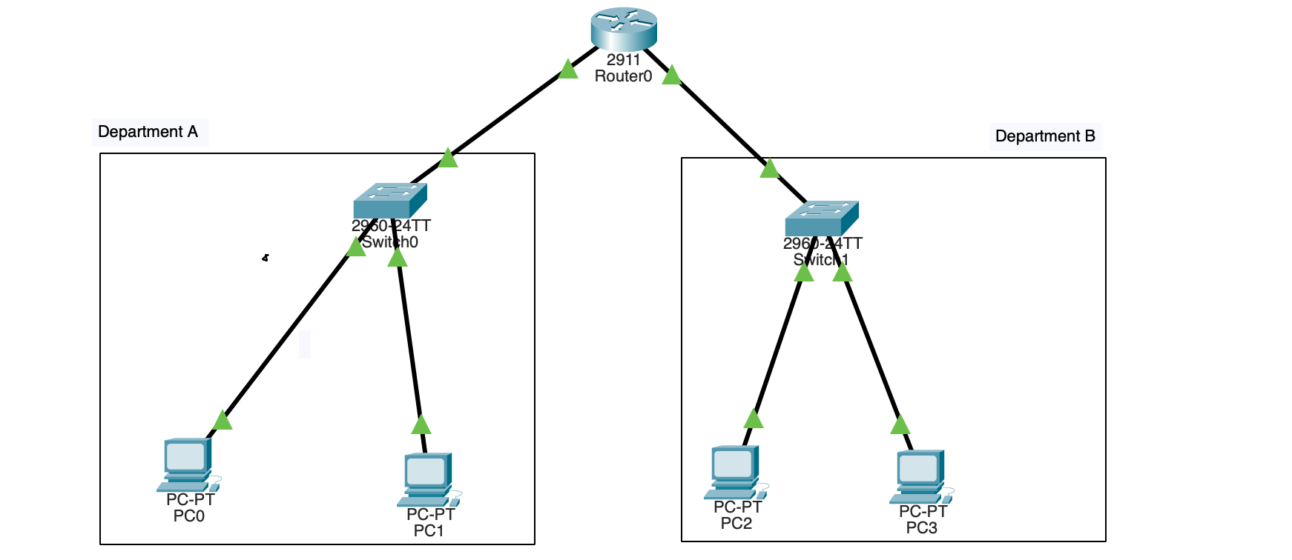

PART 6 : VERIFICATION AND TROUBLESHOOTING
- Testing Intra-Vlan Connectivity

PC0 ->PC1
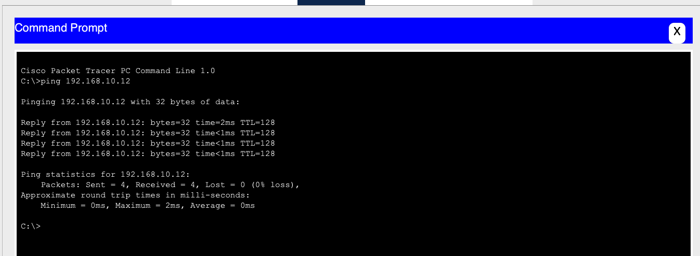

PC2 -> PC3
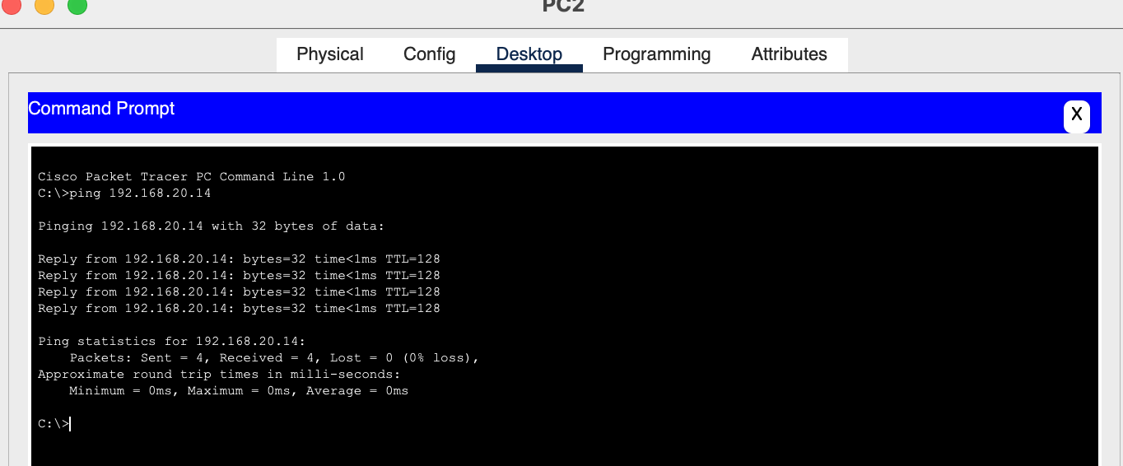
- Testing Inter-Vlan connectivity
PC0 -> PC2:
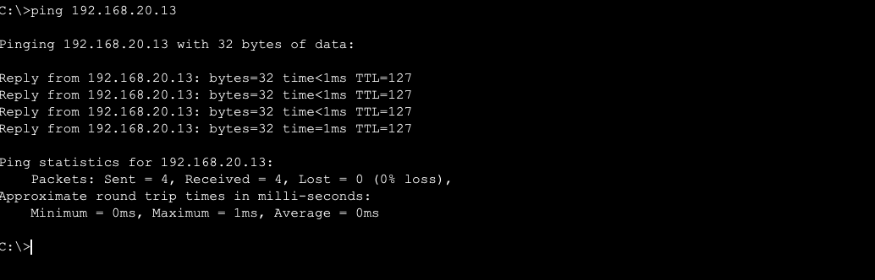

PC1 -> PC3
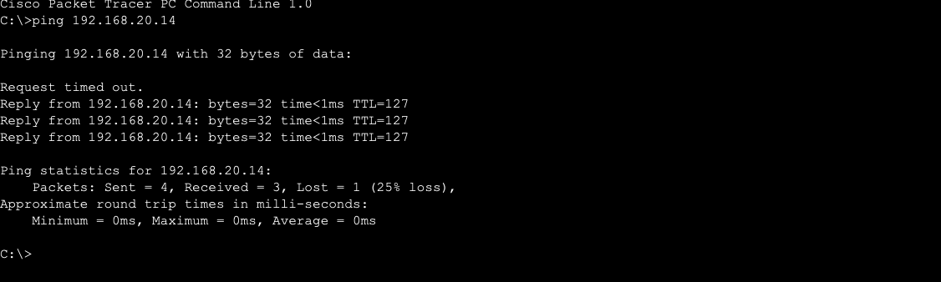

PC3 -> PC0
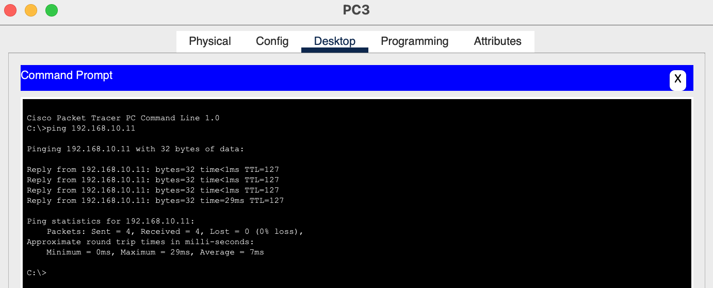

SUMMARY
In this tutorial I learnt how to create and name vlans
Assign switchports to vlan
Configure trunk and access Links
And set up router interfaces
Configuring static ip addresses

